5321 Homework 4

Fall 2019

Question Weighting:

Question 1-5 - 20 percent each

**Submittal items, for each problem**

**Submit the following in the PDF file**

1. Test case table snapshot (this is the .xlsx file)
2. JUnit pass indicator (green bar expanded so we can see values where possible)
3. JaCoCo statement green source line annotations (not JaCoCo summary)
4. Make sure to include the time stamp on your screen shots.

**Include in ZIP file**

1. Your homework solution as a pdf or Word (previous item)
2. JUnit test files (make sure problem number is referenced in the file name)
3. csv files used (make sure problem number is referenced in the file name)

**Each Java file is attached in the Blackboard zip file. Please use these files. Please do NOT modify the code - if you have to modify the code there is something wrong with your test.**

Problem 1

Use the code from Blackboard and the test cases we developed from Homework 3. Implement this using the **JUnitParamsRunner**. Use the posted class test cases from Homework 3.

**Screenshots:**

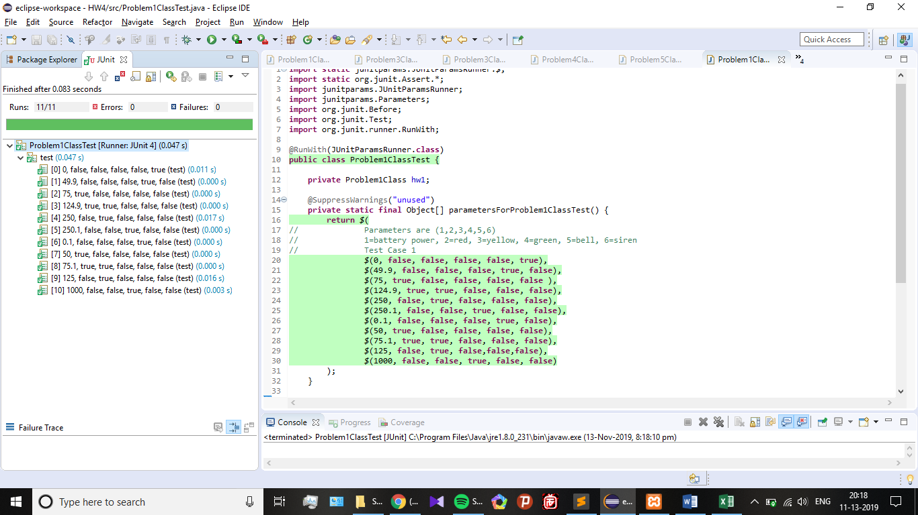

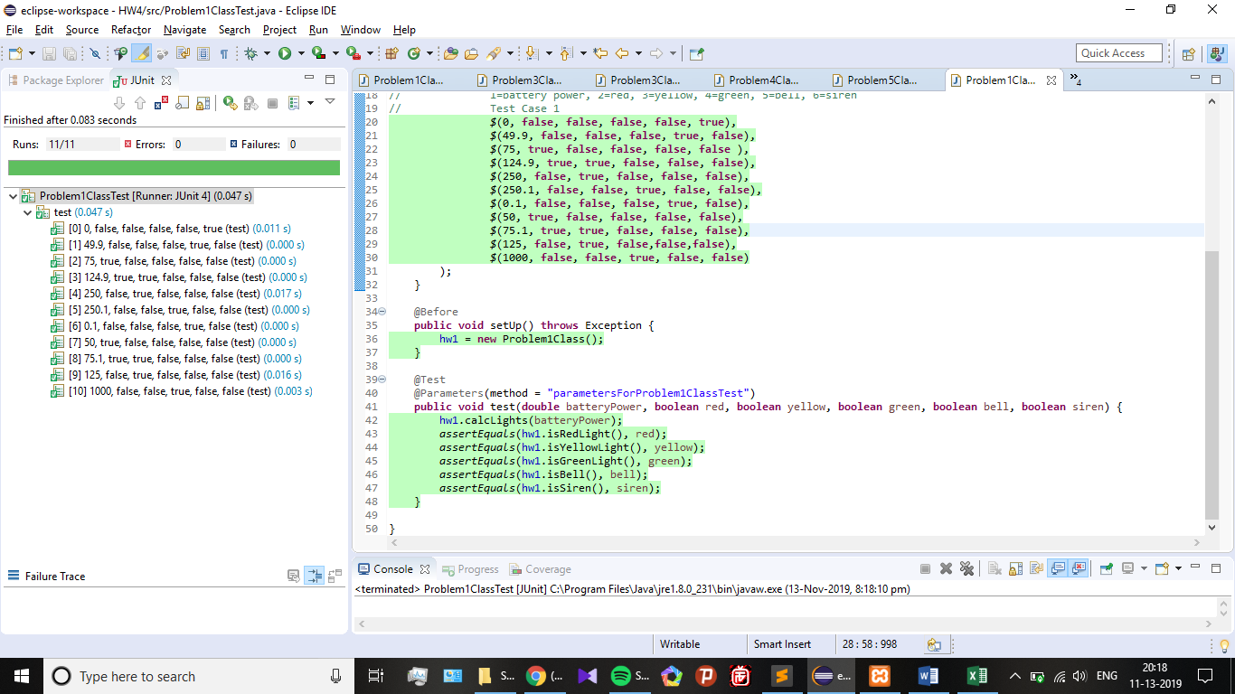

**Test Case Table:**

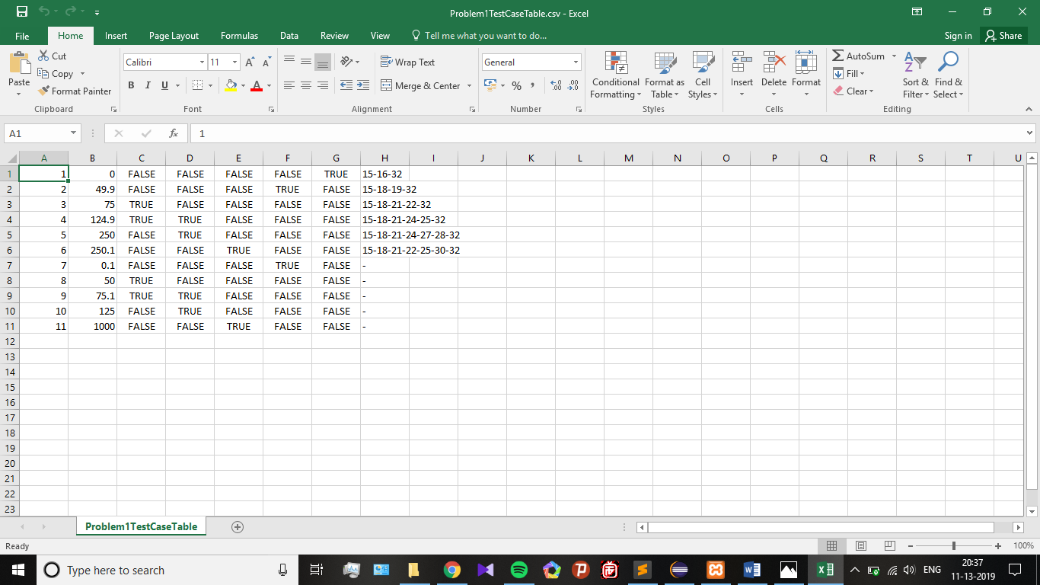

Problem 2

Use the code from Blackboard and the test cases we developed from Homework 3. Implement this as a **Parameterized.class** test. Use the posted class test cases from Homework 3. For the expected value of TotalPremium use a comparison threshold of **0.01** for assertEquals.

**Screenshots:**

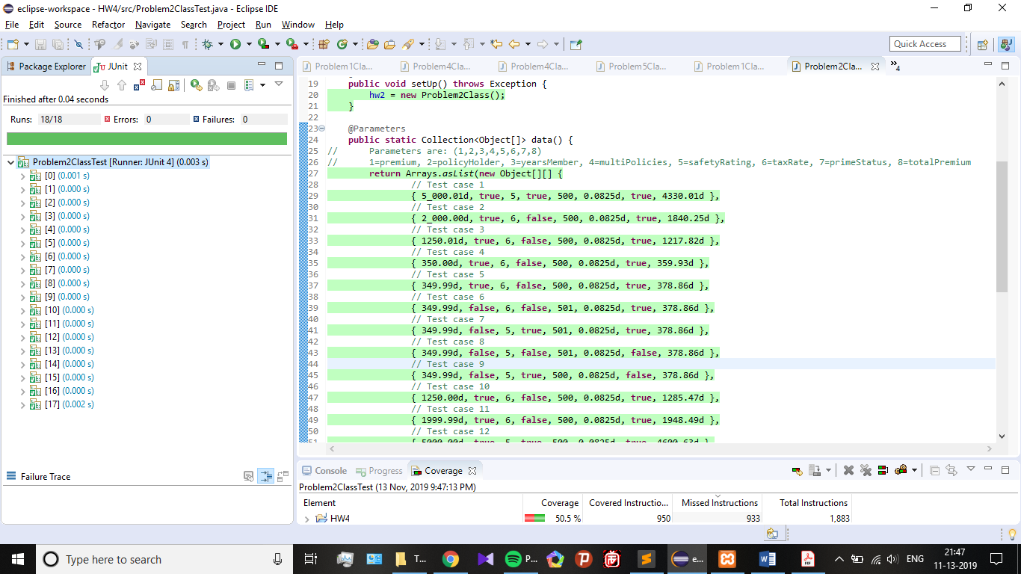

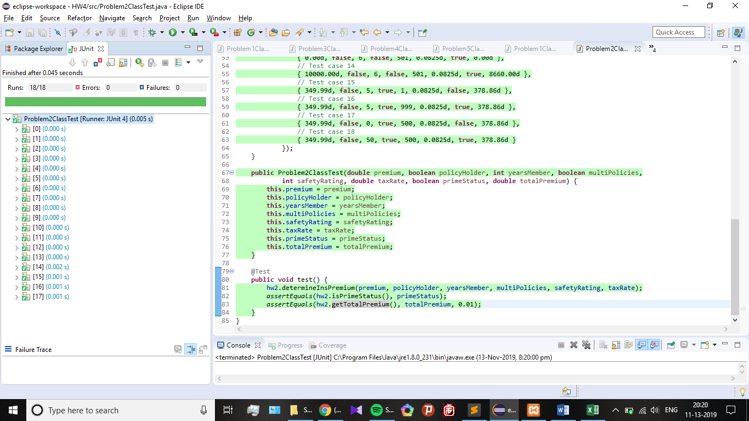

**Test Case Table:**

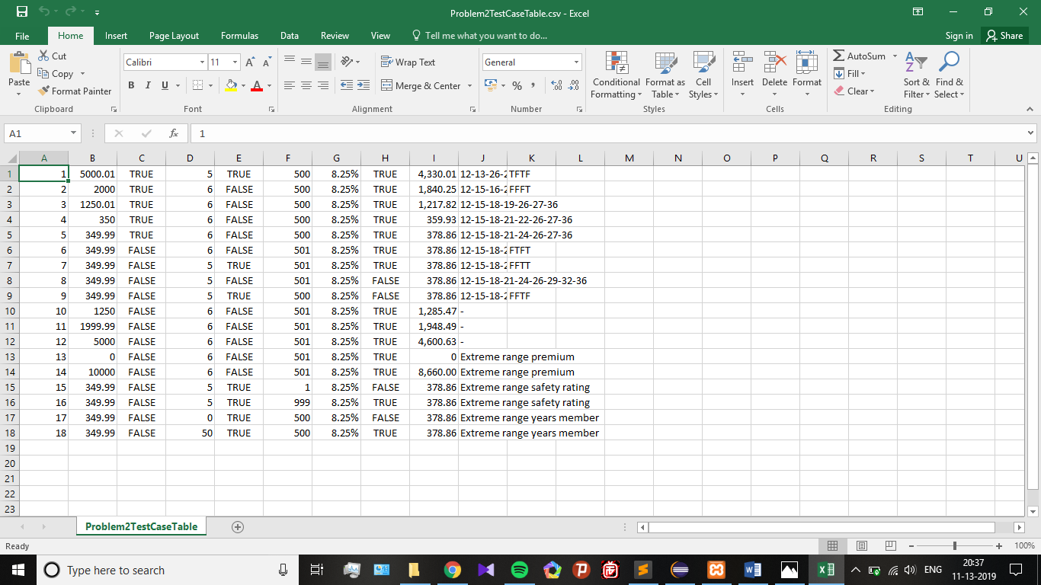

Problem 3

Use the code from Blackboard and the test cases we developed from Homework 3. Implement this using the **FileParameters** (read the values from a file). Use the posted class test cases from Homework 3.

**Screenshots:**

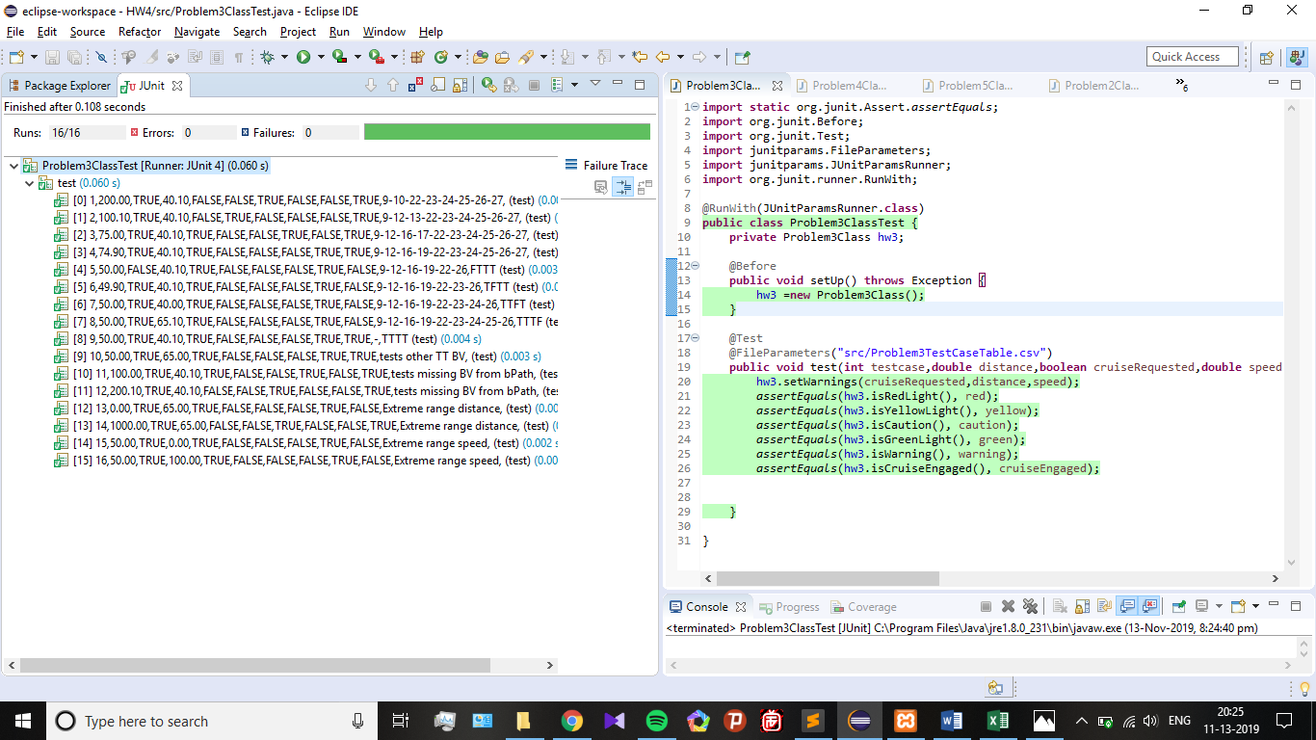

**Test Case Table:**

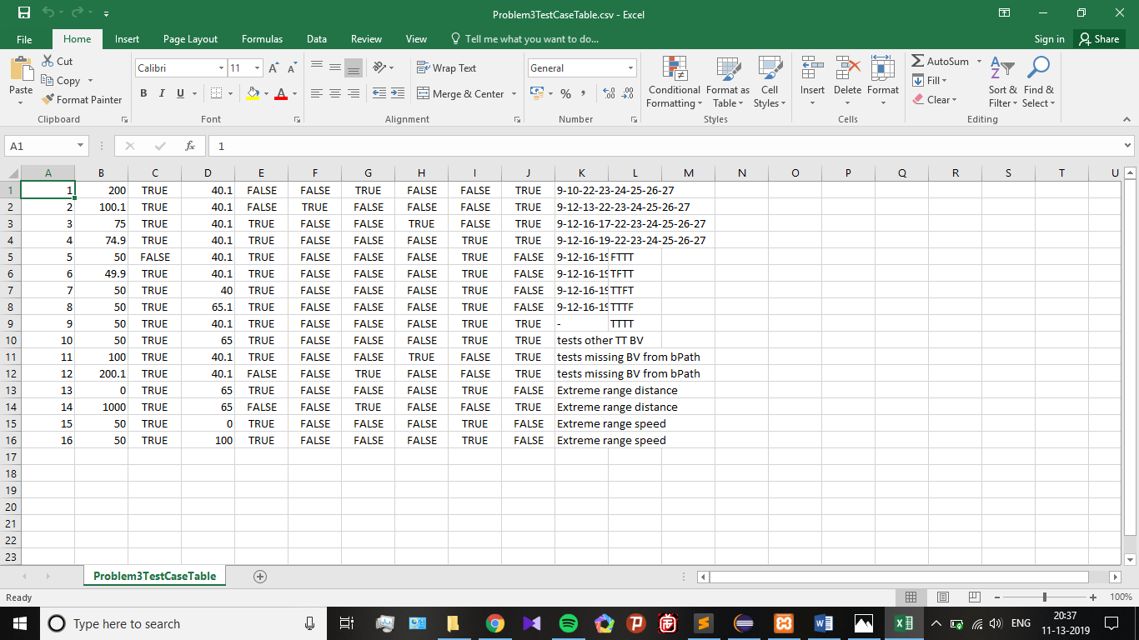

Problem 4

Use the code from Blackboard and the test cases we developed from Homework 3. Implement this using the **FileParameters** (read the values from a file). Use the posted class test cases from Homework.

**Screenshots:**

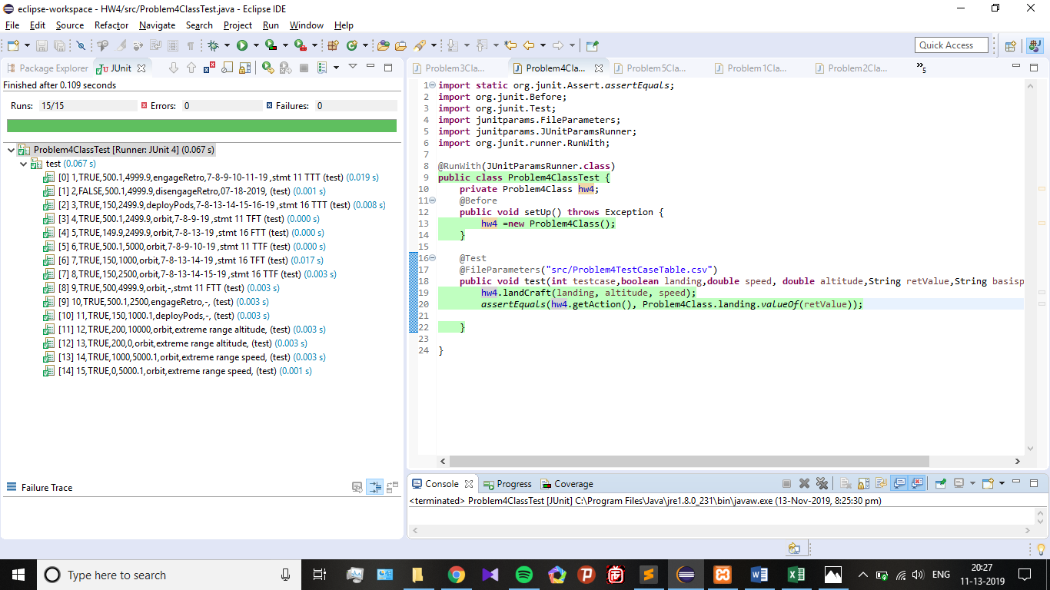

**Test Case Table:**

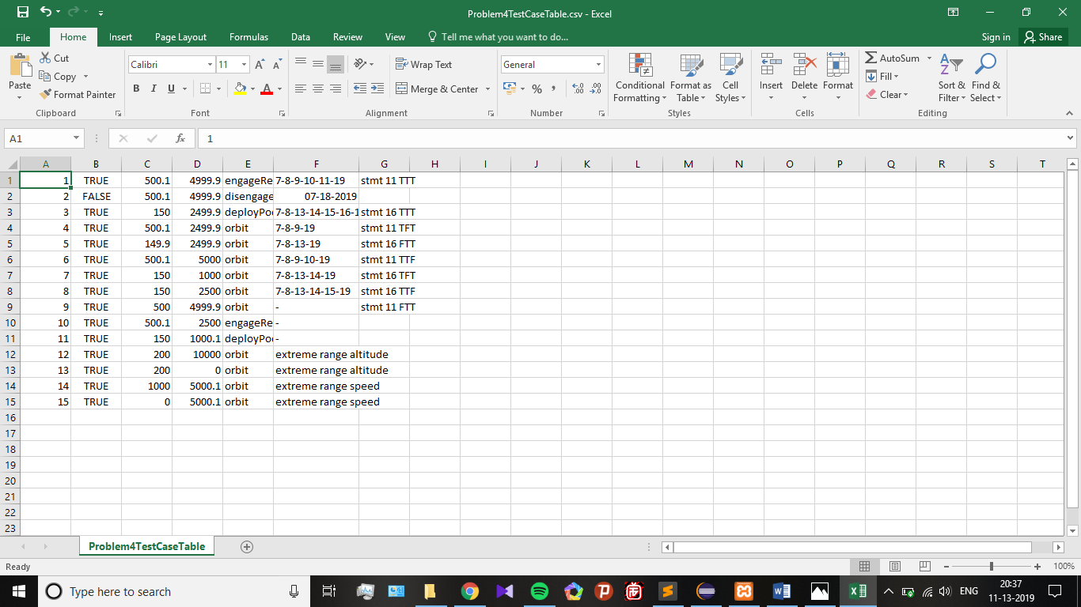

Problem 5

Use the code from Blackboard and the test cases we developed from Homework 3. Implement this using the **FileParameters** (read the values from a file). Use the posted class test cases from Homework 3. For the expected value of y use a comparison threshold of **0.001** for assertEquals.

**Screenshots:**

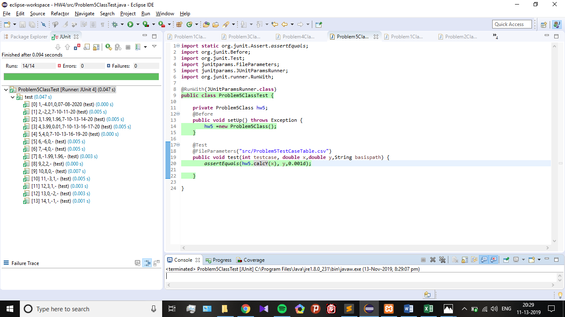

**Test Case Table:**

